IFAD- WEST AND CENTRAL AFRICA DIVISION

Prepared by:
Philip Ankomah, Private Training Expert
Contributors;
Dramani Bukari, Project Manager-IFAD-IPCI, SNV

Large Grant Agreement: 2000000473

Increasing Performance of the Cassava Industry in West and Central Africa Region (IPCI)

Training Needs Assessment for Gari Processing Industry in the Brong Ahafo Region, Ghana
Final Draft, March 2017

I F A D – W E S T A N D C E N T R A L A F R I C A D I V I S I O N
I F A D – W E S T A N D C E N T R A L A F R I C A D I V I S I O N

I F A D – W E S T A N D C E N T R A L A F R I C A D I V I S I O N
Table of Content
Figures and Tables III
Figures III
Tables IV
Acronyms IV
EXECUTIVE SUMMARY 1
1.1 Main Objective 5
1.2 Structure of the Report 5
Section I: Study Response 5
Section II: Assessment of Training Needs at Competency Domain Level 5
Section III: Recommendations 5
METHODOLOGY 6
2.1 Sampling Procedure 6
2.2 Study Instruments/Tools 6
2.3 Data Collection 7
RESULTS OF STUDY 8
3.1 Study response across processing groups 8
3.2 Socio-demographic Characteristics 8
3.2a Gender Distribution 8
3.2b Age Distribution 8
3.2c Designation of Respondents 8
3.5 Level of Education 10
3.6 Training Support 10
3.8 Respondents Satisfaction with Training Program 11
3.9 Result of Training Programs 12
3.12 SWOT Analysis of Fresh Cassava and Gari 13
Summary of Key Findings 15
4. ASSESSMENT OF TRAINING NEEDS AT COMPETENCY DOMAIN LEVEL 16
4.1 Competency Domain level 16
4.2 Need Scores Based on Competency Domains 17
4.3 Competency Domain for Cassava Farmers 18
4.3 Need Scores for Farming Based on Competency Domains 19
4.4 Staffing Plan of Gasifier Plant 20
4.4.1 Competency Domain for Gasifier Plant Staff 22
4.5 Other Expressed Needs 23
4.6 Summary of key Findings 24
5.1 Gari Processors Training Areas 26
5.2 Cassava Farmers Training Areas 27
5.3 Gasifier Plant Staff Training Areas 27
Managerial Competency Domain for Specific Portfolios 27
Technical Competency Domain for Specific Portfolios 27
5.4 Other Expressed Needs 28
Annex 1: TERMS OF REFERNCE 29

Figures and Tables

Figures
Figure 1: District Map of Techiman North District, Ghana Statistical Service, 2010 4
Figure 2: Training Support Beneficiaries, Asueyi March 2017 10
Figure 3: Type of Trainings, Asueyi March 2017. 11
Figure 4: Result of Trainings Attended, Asueyi, March 2017 12
Figure 5: Competency Domain Ranking by Need Score, Asueyi March 2017 18
Figure 6: Staffing Plan for Gasifier Plant, March 2017 21
Figure 7: Other Expressed Needs, Asueyi March 2017 23

Tables
Table 1: Sample size distribution across groups 6
Table 2: Gender of respondents 8
Table 3: Age of Respondents 8
Table 4: Current Designation of Respondent 9
Table 5: Educational Level of Respondent 10
Table 6: Respondents Satisfaction with Trainings Attended 11
Table 7: Fresh Cassava Product – SWOT Analysis 13
Table 8: Gari Processing – SWOT Analysis 14
Table 9: Competency Domain for Gari Processors 16
Table 10: Analysis of need scores by competency domain 17
Table 11: Competency Domain for Cassava Farmers 19
Table 12: Analysis of Need Scores by Competency Domain 20
Table 13: Competency Domain for Staff of Gasifier Plant 22
Table 14: Competency Domain for Specific Portfolios 22
Table 15: Training needs of Gari Processors 26
Table 16: Training needs of Farmers 26
Table 17: Other Expressed Needs 27

Acronyms

CBT Competency Based Training Policy
FUNAAB Federal University of Agriculture in Abeokuta
GASIP Ghana Agriculture Sector Investment Programme
GCWE Ghana Cassava Waste Energy
GMP Good Manufacturing Practices
HACCP Hazard Analysis and Critical Control Points
IFAD International Fund for Agricultural Development
IT Information Technology
IPCI Increasing the Performance of the Cassava Industry in West and Central Africa
MOFA Ministry of Food and Agriculture
NBSSI National Board for Small Scale industries
NRI Natural Resources Institute of Greenwich University
SNV Netherlands Development Organisation
SOP Standard Operating Procedure
SWOT Strengths, Weakness, Opportunities and Threats
TNA Training Needs Assessment
UK United Kingdom

EXECUTIVE SUMMARY
The purpose of this Training Needs Assessment is to identify the key technical and business management capacity gaps and training needs of actors within the gari processing industry in Asueyi in the Brong-Ahafo region of Ghana. This is intended to support the performance of their business management functions as cassava processing enterprises as well as the effective ownership and management of the biomass Gasifier plant on a sustainable basis. In this context, the existing level and relevant capacity needs of actors within the cassava value chain were assessed following which some recommendations have been made.
Structured data collection tools were developed and applied within the competency domain and individual skill or ability assessment framework. The results show that 42 percent of persons actively involved in the gari making business were of the Gari Queen and Queen assistant group of workers, while 28 percent were cassava farmers. Gari Roasters were 15 percent of respondents. The remaining 15 percent are found to be sievers, dryers, woodcutters, millers and peelers.
Also, persons within this industry are found to have low level of education. Fifty six percent of respondents had basic education as their highest level of education, while 18.7 percent had secondary education. Similarly, 6.5 percent had higher diplomas, while 18.8 percent had no formal education.
In the area of training, it is observed that both gari processors and cassava farmers in Asueyi have received various forms training support in the past year. Approximately 80 percent (79.3%) of respondents received training related to cassava processing and farming and found them generally satisfactory. They however see significant room for further training in terms of making the mode of delivery practical and focused on the technical aspects of gari processing and cassava farming. The training interventions have had a significant effect on financial record keeping for businesses and group development. When respondents were asked about the resultant effect of the various training programs they attended for the past year, 80 percent of the respondents pointed to the formation of the gari processors association. Fifty percent indicated they are now able to keep records of their business activities. Thirty percent indicate they have come to appreciate the process of estimating their profits and losses.
In terms of training required, the gari processors are found to be interested in acquiring managerial competency skills in the area of business management; business planning; and Leadership and system thinking skills. In order of priority, both the managerial and technical competency skills required by the processors are operating skills of the roasting and drying units of the gasifier plant; quality management skills; Cassava peel drying skills; business planning skills; environmental management; occupational safety skills; and leadership and system thinking skills.
The training needs of farmers on the other hand are found to be related to improved farming system skills. Agronomic skills had the highest need score of 42 percent, indicating the greatest gap between the levels of importance ascribed to the domain area and the existence of capacity among respondents. Weed management, pest management and disease control skills all had need scores of 40 percent. Land-use management skill and farm planning and management skills had need scores of 33 percent and 23 percent respectively in the rankings.
Staff of the gasifier plant will also require some managerial and technical skill training. The managerial skills training areas should include workplace cooperation; human resources management; and stores operation and management skills. The technical training areas should include occupational health and safety; quality management; environmental management; fortified gari processing; cassava peel drying; gasifier plant operation and management; and roasting unit operation and maintenance skills.
Other expressed training needs of both the processors and farmers include working capital, access to export market and farm implements. Specifically, the results show that 100 percent of respondents wanted working capital in the form of loans or grants to farmers to enable them expand their cassava production to increase supply. Seventy percent wants to be linked directly to the export market. Also, about 70 percent expressed the need to have a centralised milling centre. This notwithstanding, 40 percent of respondents expressed the need for farm mechanization equipment such as tractor, harvester and harrowing machine to be made available for farming through the association in the form of loan and grant arrangement.
Based on the need scores derived from the gari processors; cassava farmers and proposed staffing for the gasifier plant at the competency domain level, it is recommended that we prioritize competency areas in the following order of priority:
Training needs of Gari Processors in order of priority should include drying unit operating skills; roasting unit operating skills; business management skills; good manufacturing practices skills; cassava peel drying skills; business planning skills; environmental management skills; occupational health and safety; leadership and system thinking skills; and gari processing skills.
It is recommended that training on computer and information technology skills be made more available for literate and selected semi-literate participants in the program. The association should also be strengthened with leadership and systems thinking skills to help enforce transparency and accountability in the group for trust to prevail.
Gari processors will have to go through training and certification in quality management to meet existing national and international standards by the Food and Drugs Authority, Food Research Institute and Ghana Standards Authority.
It is recommended that we prioritize competency areas in the programs in the following order of priority: agronomic skills; weed management; pest management; disease control; land-use management; and farm planning and management for improved productivity and sustainable supply of cassava to the industry.
It is important that the key staff go through the following training programs. The steering committee, administrator and other supervisors should be trained on workplace corporation; human resource management skills; and stores operation and management skills. Staff of the gasifier plant will need training on gasifier plant operation and maintenance skills; occupational health and safety skills; and quality management skills; Other processors will need training on environmental management skills; fortified gari processing skills; cassava peel drying skills; and roasting unit operation skills.
Besides the above training needs, actors in the gari processing industry in Asueyi expressed the need for working capital, centralised milling system, direct access to the export market, farm mechanisation equipment as well as bagging and packaging machines.

BACKGROUND
“Increasing the Performance of the Cassava Industry in West and Central Africa” (IPCI) implements the Ghana Cassava Waste to Energy (GCWE) pilot project over a 3-year period. Main project partners are the Government of Ghana under the Ghana Agricultural Sector Investment Project (GASIP) of the Ministry of Food and Agriculture (MOFA), the Natural Resources Institute of Greenwich University – UK, the Federal University of Agriculture in Abeokuta (FUNAAB) Nigeria, and the International Fund for Agricultural Development (IFAD).
In line with the project implementation, SNV engaged a training consultant to conduct a Training Needs Assessment (TNA) for the project beneficiaries in Asueyi to identify key technical and business management capacity gaps and training needs. The assessment sought to draw on the training needs perceptions of gari processors and cassava farmers in Asueyi on the kind of training to offer, the curriculum to be developed and the training modality to adopt. It will also propose an overall management structure for the gasifier plant being constructed. Figure 1 is the Techiman North District map, which illustrates the location of this project.
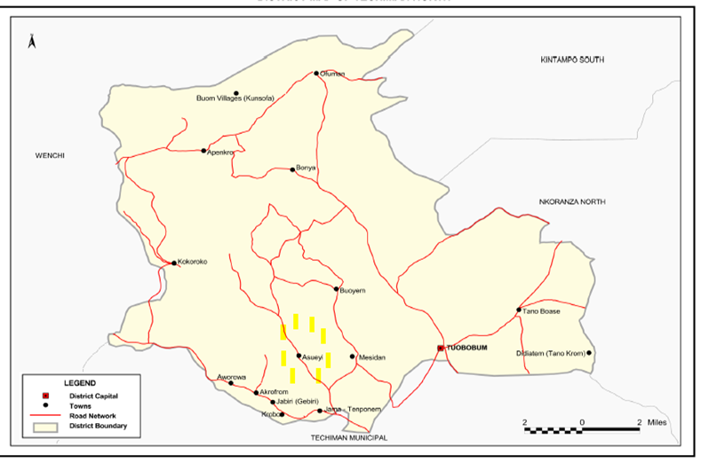
Figure 1: Map of Techiman North District, Ghana Statistical Service, 2010

1.1 Main Objective
The objectives of the study are as follows;
- Identify the key technical and management capacity gaps and relevant training needs for the effective management of cassava processing enterprises
- Identify the key technical and management capacity gaps and relevant training needs for the sustainable ownership and management of the gasifier plant
- Perform SWOT analysis of the cassava processing industry in Asueyi

1.2 Structure of the Report
The report is organised as follows;

Section I: Study Response
This section looks at the background characteristics of respondents such as gender distribution; age distribution; designation of respondents; and level of education. It also reviews previous training support received by gari value chain actors in the past year: level of satisfaction of respondents with training programs in terms of content; outcome of training programs; duration of training programs; and training method. The section finally analysis the strengths, weaknesses, opportunities and threats of cassava production and gari processing in Asueyi.

Section II: Assessment of Training Needs at Competency Domain Level
This section presents the knowledge, skills, and attitudes that were suggested by respondents and validated with the executives of the association as the necessary skill set for gari processors, cassava farmers and staff of the gasifier plant. The section also presents the results of the analysis carried out to determine the need scores at both the domain and individual skill levels.

Section III: Recommendations
This section present recommendations of training areas for gari processors, cassava farmers, and staff of the gasifier plant based on the need scores of the competency domain assessment.

METHODOLOGY
Purposive sampling approach was adopted in this study where only persons actively involved in the gari processing industry in Asueyi were selected and interviewed. These included persons from the five established individual gari processing groups, cassava farmers and other supporting workforces within the processing value chain like the peelers, who are lamped together as others.

2.1 Sampling Procedure

Stage 1—Selection of groups: The Asueyi community profile was used to generate a sampling frame. This resulted in the selection of all five (5) gari processing groups in Asueyi as the known gari processing groups.

Stage 2—Selection of gari processors and farmers: A census of processors and farmers willing to participate in the study was done for each selected group. Interviews were extended to other processors and farmers within the Asueyi community to increase the size of the sample interviewed.

Table 1: Sample size distribution across groups
Group | Sample Size
Asuogya | 10
Jackson | 20
Luckerson | 20
Nyametease | 11
Christian Mothers | 20
Farmers | 40
Others | 19
TOTAL | 140

2.2 Study Instruments/Tools
Structured data collection tools were developed for the study and were administered to respondents who had provided consent to participate in the study. The tools adopted both the competency domain and individual skill or ability assessment approach. The Competency Domain approach assisted in identifying the behaviours, knowledge, skills and abilities that are necessary for successful performance in the gari processing industry.Once the competencies were defined for particular job, actors in the gari processing industry assessed their competencies against those required for their own job, or for jobs related to the gasifier plant in which they are interested, using the two dimensions of importance or relevance and confidence.

A gap score (difference between importance and confidence) was calculated thereafter. Gap scores were determined by calculating the difference in percentages or difference in means between the two dimensions. The results were compiled and a report is provided that includes the results for all competencies, highlighting both industry players strengths as well as competencies requiring improvement. This information can be used to support the development of a learning curricula and plans for actors in the gari processing industry.

This approach is based on a competency based training policy (CBT) document prepared by the Council for Technical & Vocational Education Training of Ghana as an industry and demand-driven, outcomes-based education and training programme. Such industry standards would form the basis upon which the programme/curriculum assessment and learning materials would be designed and developed.

2.3 Data Collection

Focussed Group Discussion: Each selected group was visited. A focussed group discussion was convened for at least ten (10) members in each group present. Where some members were not present or the desired interviewee numbers were not met, more representatives were sought from other group members.
Interviews: The questionnaire was administered to at least five (5) more members in each group who were not part of the focussed group discussion.

RESULTS OF STUDY

3.1 Study response across processing groups

This section presents the findings of the TNA for the gari processing industry in Asueyi Community.

Of the estimated sample size of 100 gari processors and 40 cassava farmers interviewed, a total of 140 respondents participated in the assessment.

3.2 Socio-demographic Characteristics
This section looks at the background characteristics of respondents who took part in the survey.

3.2a Gender Distribution
Most respondents (87 percent) were female, while 13 percent were male. This ratio reflects the general gender distribution for the gari processing industry in Asueyi in the Techiman North District.
Table 2: Gender of respondents
Respondent's Gender | Frequency | Percentage
Male | 18 | 13
Female | 122 | 87

3.2b Age Distribution
About 62 percent of respondents were within the 30-49 year age range, with 25 percent of respondents less than 30 years of age. The modal age was 40 years.

Table 3: Age of Respondents
Age Group | Frequency | Percentage
< 30 years | 36 | 25
30-39 years | 28 | 20
40-49 years | 58 | 42
>50 years | 18 | 13

3.2c Designation of Respondents
About 42 percent of the respondents were of the Gari Queen and Queen assistant group of workers, while 29 percent were cassava farmers. Gari Roasters were 15 percent of respondents. This is in keeping with the observations made with the age of the respondents where the older respondents tended to be Gari Queens and Queen Assistants.
Table 4: Current Designation of Respondent
Respondents | Frequency | Percentage
Queens | 60 | 42
Roasters | 21 | 15.5
Farmers | 40 | 29
Others | 19 | 13.5

The Gari Queens are the financiers of the gari processing business. They pay every supply for the goods and services they provide in the processing of a giving quantum of gari right from cassava farmer to bagging and packaging. And they are the owners of the finished goods (gari), which they sell to their customers for a living. There are no formal conditions for a person to be a gari queen. The only condition is that you must have money to finance the processing of the gari.

The Queen Assistants are largely the spouses of the Gari Queens. They support the Gari Queens in the conduct of the gari processing business and take charge of the business whenever the Gari Queens are unable to attend to their business.

The Cassava farmers produce cassava to supply the Queens for the gari processing. According to the Gari Queens the regular, quality and quantum of cassava they are able to produce to supply the gari processing industry is key to the sustainability and growth of the gari processing industry,

The Roasters are persons who toast and stir sifted cassava mash constantly in a large but shallow stainless steel pan on fire with a wooden paddle until the gari is dry and the colour change from white to cream and crispy grains.

The others such Sievers, Peelers, Millers and Mood splitters are the core labour for the gari processing. They are hired either on permanent or casual basis to provide the aforementioned services by the Gari Queens who in turn pay them for the services at defined wages.
Peelers are persons who peel the cassava meant for gari and remove the woody tips with clean stainless steel knives.
Sievers are persons who use clean hands break the cakes of grated cassava formed due to the drying process followed by sifting with non-rusting sifter into a clean basin.
Millers are persons who grate the cassava roots in clean stainless steel graters to obtain uniform smooth mash.
Dryers are persons who bag the smooth cassava mash in clean sacks and tie it for fermentation and later pressing to squeeze liquid from the cassava mash.
Wood Splitters are engaged by Gari Queens to use the mattock in breaking up wood logs that have been brought in to be used as firewood.

3.5 Level of Education
About 56 percent of respondents had basic education as their highest level of education, while 18.7 percent had secondary education. Another 6.5 percent had higher diplomas, while 18.8 percent had no formal education as shown in Table 5 below.
Table 5: Educational Level of Respondent
Educational level | Frequency | Percentage
None | 35 | 18.7
Basic Educ. | 43 | 56.1
SHS | 15 | 18.7
Higher Diploma | 7 | 6.5

3.6 Training Support
Gari processors and cassava farmers in the Asueyi community have received various training support in the past year. About 79.3 percent of respondents received training while 20.7 percent did not go through any training related to cassava processing and farming as shown in Figure 2 below.

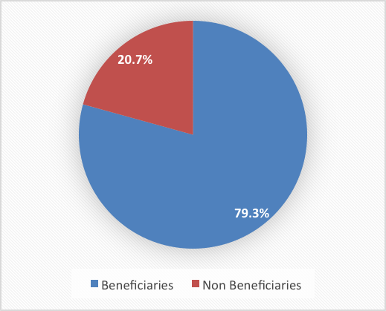
Figure 2: Training Support Beneficiaries, Asueyi March 2017

3.7 Type of Training
The study also tried to map the various trainings respondents benefitted from in the past year. Distribution by type of training respondents benefitted from showed that 100 percent of respondents benefitted from food safety and record keeping trainings, while 80 percent benefitted from training in waste management practices and 20 percent benefitted from group dynamics training as shown in Figure 3.

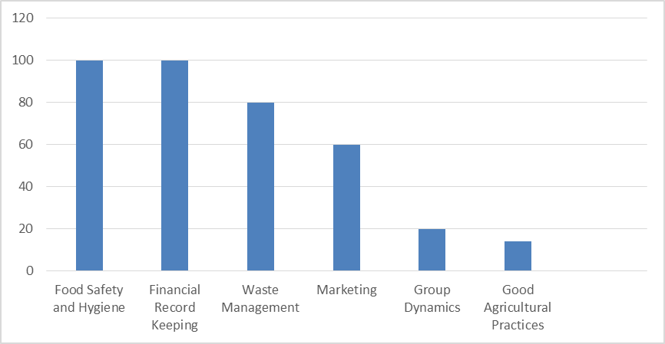
Figure 3: Type of Trainings, Asueyi March 2017.

3.8 Respondents Satisfaction with Training Program

The various training programs that participants benefitted from in the past year and their level of satisfaction with the training in terms of content and mastery of what was learnt are as follows:
Table 6: Respondents Satisfaction with Trainings Attended
Training Topic | Satisfaction (%)
Training Topic | Not Satisfied |  | Neutral |  | Satisfied
Food Safety and Hygiene | 18 | 40 |  | 37
Financial Record Keeping | 8 | 32 |  | 60
Marketing | 15 | 55 |  | 30
Group Dynamics | 5 | 25 |  | 70
Good Agronomic Practices | 0 | 35 |  | 65

Training in good agriculture practices for cassava farmers has been well appreciated by respondents as 70 percent of them were very satisfied with the knowledge and skill they acquired from it. Respondents were very satisfied with the group dynamics training as 60 percent indicated in their response. Training in food safety and hygiene as well as marketing though enlightening to respondents, they were not very satisfied with it because it was a bit generic in content and has not improved their market and food safety practices.

3.9 Result of Training Programs

When respondents were asked about the resultant effect of the various training programs they attended for the past year, 80 percent of the respondents indicated the formation of the umbrella gari processing group. About 50 percent indicated they keep records of their business activities. 30 percent indicated they have come to appreciate calculating their profits and losses as shown in figure 3 above. The survey results show that 80 percent of training programs organised for respondents were one-day programs. 20 percent were done for three days continuously. The mode of training as shown by the survey took the form of lecture and power point presentations.

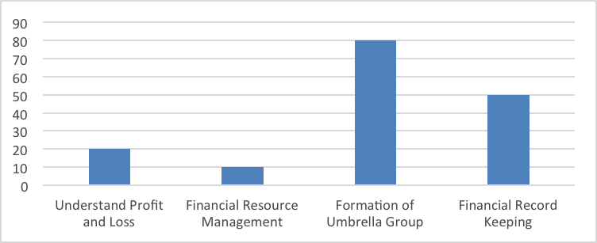
Figure 4: Result of Trainings Attended, Asueyi, March 2017

3.12 SWOT Analysis of Fresh Cassava and Gari
The following section highlights the strengths, weakness, opportunities and threats for fresh cassava and gari. The results have been summarised in Tables 13 and 14 below.

Table 7: Fresh Cassava Product – SWOT Analysis
Strengths Weakness Weaknesses
- Available land good for cassava cultivation.  - Variety of cassava produced is good for end-use.  - Use of high yielding cultivars for production.  - Community well noted as key cassava production area.  - Availability of labour for production. | - Poor pest and weed management in cassava farms.  - Poor land-use management affecting productivity with time.  - Labour intensive method of production makes production time consuming  - The youth are not interested in cassava farming.
Opportunities | Threats
- Existing demand for fresh cassava exceed supply.  - MoFA and its partners are providing regular technical support for cassava production.  - New and improved value addition options available for farmers to adopt and earn high income ( HGCF, starch, ethanol, gari)  - New and improved high yielding cultivars developed and multiplied.  - Good price for fresh cassava as the market tend to be suppliers market | - Huge competition from cashew and cocoa farmers for acquisition and use of land for cassava farming.  - Cassava farmers converting parts of their cassava farms to cashew farms.  - Invasion of farmlands by army warms affecting productivity.  - Increasing cost of labour and inputs.  - Too much reliance on rainfall pattern for production makes production seasonal.  - The existence of middlemen (market Queens) in the supply chain who buy from farmers at low price and sell at higher price to end-user.

Table 8: Gari Processing – SWOT Analysis
Strengths Weaknesses
- High demand in Ghana in our homes and institutions.  - We produce two varieties of gari  (plain gari and plam oil fortified gari).  - Gari is a delicacy for both the rich and poor in society.  - Affordable price for all to buy.  - Informal collective bargaining for uniform price,  - Production is done in groups for regulation and promotion of best practices | - Inadequate working capital to purchase adequate raw materials.  - The nature of production is drudgery and introduces dirt to the final product.  - Inefficient energy usage mechanism.  - Processors are exposed to excessive heat and smoke leading to long term illness.  - Production process is not standardised and certified for access to formal markets
Opportunities | Threats
- Huge underserved high-end market in Ghana and export market.  - Availability of improved cook stove and energy supply technology to reduce exposure to heat and smoke.  - Availability of different varieties of gari such as gari fortified with soya beans, margarine etc.  - Location in cassava production area which makes it easy to access.  - Large-scale mechanisation of gari production will make it competitive for beneficiaries in terms of prices, and raw material supply arrangements. | - Scarcity of cassava in the dry season.  - Aggregators (Market Queens) in the formal and export markets who buy at low price and sell for higher price.  - Scarcity of firewood due to depletion of forest.

Summary of Key Findings
The results of the analysis show to what extent females play a major role in the gari processing industry in Asueyi. Most respondents (87 percent) were female.
Majority of persons involved in the gari processing industry are of mature age and form part of the active population as 62 percent of respondents were within the 30-49 year age range.
The results of the survey show that the gari processing industry provides various employment and income generating opportunities for community members including the Gari Queen and Queen assistant group of workers, cassava farmers, Gari Roasters, Sievers, Dryers, Wood Cutters, Millers and Peelers.
Majority of actors in the gari processing industry have low level of education. About 56 percent of respondents had basic education as their highest level of education.18.8 percent had no formal education.
Majority of gari processors and cassava farmers in the Asueyi community have received various training support in the past year. About 79.3 percent of respondents received training related to cassava processing and farming.
Gari Processors and Cassava Farmers in Asueyi have been taken through a significant number of training interventions related to their jobs. Key among them is food safety, financial record keeping trainings, waste management practices and group dynamics training.
Gari processors in Asueyi and cassava farmers are satisfied with the trainings they have received in terms of content and mastery of what they learnt. But they see a significant room for improvement in terms of making the mode of delivery practical and adapting content to focus more on the gari processing industry and cassava farming
Training interventions have had a significant effect on financial record keeping for businesses and group development.

4. ASSESSMENT OF TRAINING NEEDS AT COMPETENCY DOMAIN LEVEL

4.1 Competency Domain level
These are knowledge, skills, and attitudes that were suggested by respondents and validated with executives of the association as necessary skill set for gari processing and marketing; and organisational development. These competencies have been compared with the current job descriptions of actors in the gari processing and cassava farming industry and determined by the training expert to be appropriate for use in the Asueyi Community gari processing industry.

Table 9: Competency Domain for Gari Processors
Domain | Description
Managerial Competencies
Business Planning Skills | Skills related to the development of Marketing Plan; Organisational and Capacity Development Plan; Costing; and Financial Plans to guide the growth and management of their businesses
Business Management Skills | Skills related to developing and managing a gari processing facility, develop business operating procedures and follow through it implementation.
Leadership and Systems Thinking Skills | Skills related to utilizing leadership characteristics,  serving as a group leader, and establishing mentoring, peer advising, and other professional development opportunities for the other gari processing actors
Technical Competencies
Occupational Safety and health Skills | Skills related to ability to reduce accidents at the workplace and its related cost to the barest minimum.
Quality Management | Skills related to production processes aimed at meeting national standards to certify participation in formal markets.
Environmental Management Skills | Skills related to ensuring the initiation and participation of gari processors in identifying major environmental problems posed by their business and develops their capacity to put environmental management mechanisms in place.
Improved Gari variety processing Skills | Skills related to production of gari variety tailored to meet market needs, packaging etc.
Cassava Peel Drying Skills | Skills related to gathering, drying and packaging of cassava peels to meet requirements on gasifier plant
Roasting Unit Operation Skills | Skills related to using the new roasters to produce quality gari in a way that do not destroy the new roasters
Drying Unit Operation Skills | Skills related to using the new drying unit for fermenting and pressing quality cassava mash in a way that do not destroy the new drying area and pressing equipment

4.2 Need Scores Based on Competency Domains

Respondents were asked to assess themselves along the lines of the competency domains on how important it is for them to have the set of skills and how confident they are in their ability to demonstrate the set of skills.

Analysis was carried out to determine the need score at both the domain and individual skill levels as shown in table 13 above. The needs assessment used two dimensions: 1) importance or relevance of the competency domain area; and 2) confidence in each competency domain area. Each dimension was graded into three categories (not important, neutral, important; and not confident, neutral, and confident). This allowed for the calculation of need scores, determined by calculating the difference in the proportion of respondents who indicated the competency domain was important and the proportion of respondents who indicated confidence in their ability to perform the competency. For example, 67 percent reported that industrial gari plant operating domain competencies were important but only 12 percent indicated that they felt confident in this domain area, then the 55 percent of respondents who felt the skill was important but did not indicate feeling confident would be in need of some kind of training in that skill. The scores assumed that respondents who reported a “neutral” confidence level were also in need of training.

Table 10: Analysis of need scores by competency domain

Domain Area | Importance  (Means) |  |  | Confidence  (Means) |  |  | Need  Score*
Domain Area | Not  Important | Neutral | Important | Not  Confident | Neutral | Confident | Need  Score*
Managerial Competence
Business Management Skills | 2 | 28 | 70 | 13 | 57 | 30 | 40%
Business Planning Skills | 3 | 40 | 59 | 17 | 48 | 35 | 24%
Leadership and system thinking Skills | 2 | 21 | 77 | 8 | 30 | 62 | 15%
Technical Competence
New Roasting Unit operating skill | 1 | 32 | 67 | 38 | 50 | 12 | 55%
New Drying Unit operating skill | 1 | 32 | 67 | 38 | 50 | 12 | 55%
Quality Management Skills | 0 | 32 | 68 | 17 | 51 | 32 | 36%
Cassava Peel drying  Skills | 0 | 40 | 60 | 14 | 55 | 30 | 30%
Environmental management Skills | 0 | 26 | 74 | 1 | 47 | 52 | 22%
Occupational Safety and Health Skills | 9 | 35 | 56 | 15 | 50 | 35 | 21%
Improved Gari variety processing Skills | 3 | 22 | 75 | 8 | 30 | 62 | 13%
*Proportion of study participants in need of training in the competency domain

From Table 4 above, under technical competencies the new roasting unit as well as drying unity-operating skills had the highest need score of 55 percent, indicating the greatest gap between the levels of importance ascribed to the domain area and the existence of the capacity among respondents.
Under the managerial competencies, business management skills and business planning skills had need scores of 40 percent and 30 percent respectively. Table 5 provides a graphical representation of the need score ranking.

Figure 5: Competency Domain Ranking by Need Score, Asueyi March 2017

4.3 Competency Domain for Cassava Farmers
These are knowledge, skills, and attitudes that were suggested by respondents and validated with the executives of the association and training experts as necessary skill set for cassava farming and marketing; and organisational development.

Table 11: Competency Domain for Cassava Farmers
Domain | Description
Managerial Competencies
Farm Planning and Management Skills | Skills related to the development of crop calendar and KPIs to ensure effective functioning of the cassava farming business based on production standards.
Technical Competencies
Agronomic Skills | Skills related to the science and technology for producing and harvesting cassava for high yields.
Weed Management Skills | Skills related to keeping weed population in cassava farms below the level of economic injury to the cassava crop with minimum environmental pollution.
Pest Management Skills | Skills related to keeping pest population in cassava farms below the level of economic injury to the cassava crop with minimum effect on environment and human population.
Disease Control Skills | Skills related to diagnosis, identification and control of diseases that attack cassava farms.
Land-Use Management Skills | Skills related to maintenance of farm land for optimum production output on sustainable basis.

4.3 Need Scores for Farming Based on Competency Domains

Respondents were asked to assess themselves along the lines of the competency domains on how important it is for them to have the set of skills and how confident they are in their ability to demonstrate the set of skills.

Analysis was carried out to determine the need score at both the domain and individual skill levels. Under technical competencies, 77 percent reported that agronomic domain competencies were important but only 35 percent indicated that they felt confident in this domain area, then the 42 percent of respondents who felt the skill was important but did not indicate feeling confident would be in need of some kind of training in that skill. The scores assumed that respondents who reported a “neutral” confidence level were also in need of training
Table 12: Analysis of Need Scores by Competency Domain
Domain Area | Importance  (Means) |  |  | Confidence  (Means) |  |  | Need  Score*
Domain Area | Not  Important | Neutral | Important | Not  Confident | Neutral | Confident | Need  Score*
Managerial Competence
Farm Planning and Management Skills | 10 | 35 | 55 | 25 | 43 | 32 | 23%
Technical Competence
Agronomic skill | 1 | 22 | 77 | 12 | 53 | 35 | 42%
Weed Management Skills | 2 | 25 | 73 | 10 | 57 | 33 | 40%
Pest Management Skills | 2 | 25 | 73 | 10 | 57 | 33 | 40%
Disease Control Skills | 2 | 25 | 73 | 10 | 57 | 33 | 40%
Land-use Management Skills | 0 | 38 | 62 | 20 | 51 | 29 | 33%
*Proportion of study participants in need of training in the competency domain

From Table 17 above, agronomic skills had the highest need score of 42 percent, indicating the greatest gap between the levels of importance ascribed to the domain area and the existence of the capacity among respondents. Weed Management, Pest Management and Disease Control skills all had need scores of 40 percent. Land-use management skill and farm planning and management skills had need scores of 33 percent and 23 percent respectively in the rankings. Table 7 provides a graphical representation of the need score ranking.

4.4 Staffing Plan of Gasifier Plant
After a series of focussed group discussions with the gari processing groups, it is recommend that thirteen (13) staff are engaged in the medium term for the efficient running of the plant. The Association through its annual general meetings must be the highest decision making body of the gasifier plant operation. A steering Committee made up of persons who must have a maximum period they can serve on it will constitute the company board. The day to day running of the gasifier plant will be conducted by a thirteen (13) member team headed by an Administrator who reports to the company board. The company board (steering Committee) shall report to the association through their annual general meetings. The proposed staffing plan for the gasifier plant is found in figure 6.
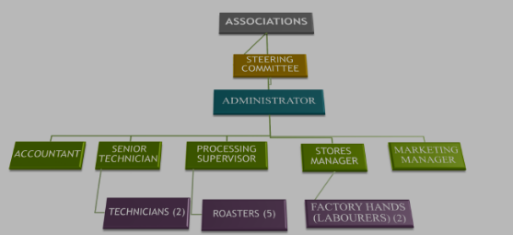
Figure 6: Staffing Plan for Gasifier Plant, March 2017
Administrator: Institute and manage human resources and administrative policies that ensure industrial harmony in the company. Represent the company at all high level meetings. Ensure effective liaison and maintain a very strong positive relationship between the company and its development partners, particularly its bankers, suppliers, customers, regulators, and employees.

Accountant: Promote cost effective application of funds. Implement corporate financial accounting policies and procedure. Prepare corporate accounts and other financial reports.
Technician: Ensure equipment alignment for cost effective production flow. Implement planned maintenance program to minimise downtime. Undertake mechanical and electrical repair when a machine breaks down. Provide technical advice to management on state of machines and equipment. The person will be assisted by a mechanical technician and an electrical technician.
Processing Supervisor: Ensure factory hygiene and sanitation as well as safety and health of production workers through administration of well-defined standard operating procedure, good management practices, and hazard analysis and critical control points procedures. Ensure product quality management through sample testing and adherence to international and national quality standard. The roasters work under the supervisor.
Stores Manager: Responsible for inventory control by maintaining proper accounting and audit trail for finished products, materials and tools received.
Marketing Manager: Responsible for maintaining business relationship with existing buyers. Embarking on marketing drive to identify and secure new market for the produce.

4.4.1 Competency Domain for Gasifier Plant Staff
These are knowledge, skills, and attitudes that were suggested by respondents and validated with the executives of the association and training experts as necessary skill set for sustainable management of gasifier plant.
Table 13: Competency Domain for Staff of Gasifier Plant
Domain | Description
Managerial Competency
Workplace Cooperation Skills | Skills needed to establish a systematic approach to make enterprise improvements and track progress
Human Resource Management Skills | Skills to maximise employee performance in service of an employer’s strategic objectives.
Stores Operation and Management Skills | Skills for inventory control by maintaining proper accounting and audit trail for materials and tools received.

It is important that the key staff go through the following training programs.
Table 14: Competency Domain for Specific Portfolios
Domain | Target
Managerial Competency
Workplace Cooperation Skills | Plant Administrator; Steering Committee; Marketing Manager
Human Resource Management Skills | Plant Administrator; Steering Committee
Stores Operation and Management Skills | Administrator; Stores Manager
Technical Competency
Occupational Safety and health Skills | Technicians; Processing Supervisor; Stores Manager; Roasters; Factory hands
Quality Management | Processing Supervisor; Roasters; Stores Manager
Environmental Management Skills | Processing Supervisor; Stores Manager; Technicians; Roasters; Factory hands
Fortified gari processing Skills | Processing Supervisor; Roasters
Cassava Peel Drying Skills | Senior Technician; Technicians
Gasifier Plant Operation and Maintenance Skills | Senior Technician; Technicians
Roasting Unit Operation Skills | Senior Technician; Technicians; Processing Supervisor; Roasters

4.5 Other Expressed Needs
Figure 5 below gives a summary of other expressed needs of the gari processors and cassava farmers during the TNA.
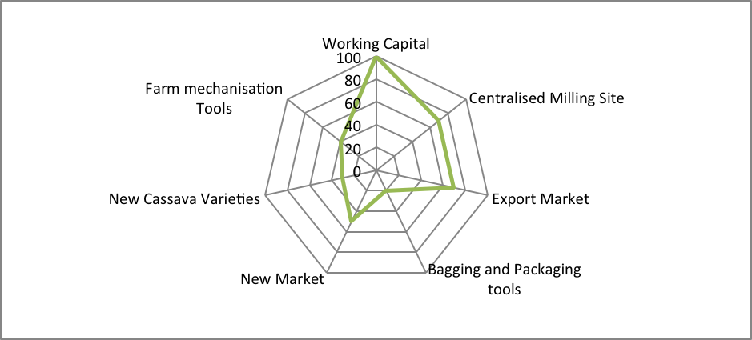
Figure 7: Other Expressed Needs, Asueyi March 2017
The results show that 100 percent of respondents wanted working capital in the form of loan or grant to enable the farmers expand their cassava production to increase productivity. Again, 70 percent of respondent wanted assistance to be linked directly to the export market as existing arrangements where they produce for middlemen to buy at lower rates and repackage for export is not financially rewarding and it is the middlemen who benefit financially. Not all, 70 percent expressed the need to have a centralised milling centre very close to the new drying centre under construction where all groups will site their cassava milling machines. This notwithstanding, 40 percent of respondents expressed the need for farm mechanization equipment such as tractor, harvester and harrowing machine to be made available for farming through the Association in the form of loan and grant arrangement. These mechanization machines would be rented to cassava farmers to enable them till and cultivate with relatively little effort.

4.6 Summary of key Findings
Results of the analysis carried out show the knowledge, skills, and attitudes that are necessary skill set for gari processing and marketing; and organisational development include business planning skills, occupation safety and health skills, quality management skills, improved gari variety processing skills, business management skills, environmental management skills, leadership and systems thinking skills, cassava peel drying skills, new roasting unit operating skills and new drying unit operating skills.
Majority of gari processors are interested in acquiring skill related to services they are to deliver in relation to the gasifier plant being constructed. The new roasting unit as well as drying unit operating dimensions skills had the highest need score of 55 percent, indicating the greatest gap between the levels of importance ascribed to the domain area and the existence of the capacity among respondents. Business management skills and quality management skills had need scores of 40 percent and 36 percent respectively. Cassava peel drying and business planning skills had need scores of 30 percent and 24 percent respectively. Environmental management and occupational safety skills both had 21 percent need scores. Leadership and system thinking skills and gari processing skills had the lowest need score of 15 percent and 13 percent respectively in the rankings.
The knowledge, skills, and attitudes that are necessary skill set for gari processing and marketing; and organisational development include agronomic skills; weed management; pest management; disease control skills; land-use management skill; and farm planning and management skills.
Cassava farmers are interested in acquiring skills related to improved farming systems. Agronomic skills had the highest need score of 42 percent, indicating the greatest gap between the levels of importance ascribed to the domain area and the existence of the capacity among respondents. Weed management, pest management and disease control skills all had need scores of 40 percent. Land-use management skill and farm planning and management skills had need scores of 33 percent and 23 percent respectively in the rankings.
The gasifier plant in the medium term will need additional key staff like the processing supervisor; stores manager; marketing manager; and two more technicians for the efficient operation of the investment.
It is important that the key staff go through a variety of managerial and technical skill training programs. The managerial skills training areas include workplace cooperation; human resources management; and stores operation and management skills. The technical training areas include occupational safety and health; quality management; environmental management; fortified gari processing; cassava peel drying; gasifier plant operation and management; and roasting unit operation and maintenance skills.
The gari processors and cassava farmers have other needs. The results show that 100 percent of respondents wanted working capital in the form of loan or grant to enable the farmers expand their cassava production to increase productivity. Again, 70 percent of respondent wanted assistance to be linked directly to the export market as existing arrangements where they produce for middlemen to buy at lower rates and repackage for export is not financially rewarding and it is the middlemen who benefit financially. Not all, 70 percent expressed the need to have a centralised milling centre. This notwithstanding, 40 percent of respondents expressed the need for farm mechanization equipment such as tractor, harvester and harrowing machine to be made available for farming.
5. RECOMMENDATIONS

5.1 Gari Processors Training Areas
Based on the need scores derived from the gari processors at the competency domain level, it is recommended that we prioritize competency areas in the programs in the following order of priority:
Table 15: Training needs of Gari Processors
s/n | Training needs | Need scores
Managerial Competence
3 | Business Management Skills | 40%
6 | Business Planning Skills | 24%
9 | Leadership and system thinking Skills | 15%
Technical Competence
1 | Roasting Unit Operation Skills | 55%
2 | Drying Unit Operation Skills | 55%
4 | Good Manufacturing Practices Skills | 36%
5 | Cassava Peel drying Skills | 30%
7 | Environmental management Skills | 22%
8 | Occupational Safety and Health Skills | 21%
10 | Gari processing Skills | 13%
It is recommended that training on computer and information technology skills be made more available for literate and selected semi-literate participants in the program.
The umbrella group must be strengthened. The leadership and systems thinking skills will help enforce transparency and accountability mechanisms in the group for trust and communication to prevail.
Gari processors will have to go through training and certification in quality management to meet existing national and international standards by the Food and Drugs Authority, Food Research Institute and Ghana Standards Authority.

5.2 Cassava Farmers Training Areas
Based on the need scores derived from the cassava farmers at the competency domain level, it is recommended that we prioritize competency areas in the programs in the following order of priority:
Table 16: Training needs of Farmers
s/n | Training needs | Need scores
Technical Competence
1 | Agronomic skill | 42%
2 | Weed Management Skills | 40%
3 | Pest Management Skills | 40%
4 | Disease Control Skills | 40%
5 | Land-use Management Skills | 33%
Managerial Competence
6 | Farm Planning and Management Skills | 23%

It is recommended that we prioritize competency areas in the programs in the following order of priority: agronomic skills; weed management; pest management; disease control; land-use management; and farm planning and management for improved productivity and sustainable supply of cassava to the industry.

5.3 Gasifier Plant Staff Training Areas
It is important that the key staff go through the following training programs.

Managerial Competency Domain for Specific Portfolios
The steering committee, administrator and other supervisors are to be trained on workplace corporation; human resource management skills; and stores operation and management skills.

Technical Competency Domain for Specific Portfolios
Staff of the gasifier plant will need training on occupational health and safety skills; quality management; environmental management skills; fortified gari processing skills; cassava peel drying skills; gasifier plant operation and maintenance skills; and roasting unit operation skills.

5.4 Other Expressed Needs
Table 17: Other Expressed Needs
s/n | Training needs | Need scores
1 | Working Capital | 100%
2 | Centralised Milling Site | 70%
3 | Linkage to Export Market | 70%
4 | Linkage to Additional Market | 50%
5 | Farm Mechanization Equipment | 40%
6 | Bagging and Packaging Machine | 20%
7 | New Cassava Varieties | 30%

It is recommended that above expressed needs are given priority in the design of an up-scale program. Bagging and Packaging machines may be provided to enable them supply to formal markets. Effort must be made to link them to export and additional market. Farmers will need access to farm mechanization equipment like tractor, harrowing machine and harvester for increased productivity.

Annex 1: TERMS OF REFERNCE

TERMS OF REFERENCE (TOR) FOR CONSULTANT – COMMUNITY ANIMATION
ASUEYI, NEAR TECHIMAN – BA Region
SNV
SNV is a not-for-profit international development organization. Founded in the Netherlands 50 years ago, we have built a long-term, local presence in 38 countries in Asia, Africa and Latin America. At SNV, we aim not only to improve individual lives, but to contribute to global challenges in three key areas that strongly impact the poor – Agriculture, Energy and Water, Sanitation & Hygiene.
Present in Ghana since 1992, SNV is committed to the reduction of poverty, and works to achieve this in line with national poverty reduction strategies. The overall goal of SNV Ghana’s Energy programme is to develop the sustainable energy market by providing equitable access to affordable and efficient energy solutions to households, institutions and small and medium enterprises. Our interventions have been deployed in areas of Improved Cookstoves (ICS), Sustainable Fuels and Waste to Energy, Biogas for domestic and productive use, and Small Solar Off-grid solutions. Through our local presence, SNV continues to strengthen local and national stakeholders in order to develop sustainable ICS markets, to promote innovative technologies and to create an enabling environment, stimulating private sector involvement.
SNV has secured a grant from one of its development partners to implement the project “Increasing the Performance of the Cassava Industry in West and Central Africa” over a 3-year period. Main project partners are the Government of Ghana through MOFA-GASIP, the Natural Resources Institute of Greenwich University – UK, the Federal University of Agriculture in Abeokuta (FUNAAB), Nigeria and the Int. Fund for Agricultural Dev’t. (IFAD).
In line with the project implementation, SNV wishes to hereby apply part of its fund received for the procurement of a Consultant to support project activities at the Asueyi project site, near Techiman in the Brong Ahafo Region. The successful candidate shall be expected to generally support with project implementation as explained below under the item “Job Description”.

PROJECT BRIEF/OBJECTIVES
The project “Increasing the Performance of the Cassava Industry in West and Central Africa” (IPCI) is to enhance the performance of IFAD-funded national root and tuber crops projects. Project duration November 2014 – December 2017 and the grant closing date is 30th June 2018.
The IPCI is also expected to have a wider regional impact through the following work packages:
- Stock-taking and dissemination of good practice and lessons learned;
- Introduction and dissemination of technological innovations;
- Enhancement of policy dialogue among relevant actors;
- Increasing private sector involvement and promoting private-public partnerships (PPP’s).
SNV’s work under the IPCI is largely based under work package 1 & 2.

SCOPE OF WORK/JOB DESCRIPTION
The suitable candidate will be responsible to do the following;

Task 1 – Community Entry & Profiling
SNV has already entered the Asueyi community and has started some level of engagement with major stakeholders (e.g. MOFA Directorate and Gari Processors). The Consultant is expected to continue and build upon these important relationships to trigger a stronger cooperation between the community and other partners for project success. In profiling the Asueyi community, the Consultant shall collect relevant information which will include:
- Location
- Number of households,
- Population (general, gari/cassava processors and other agro processing industries – if any),
- Cassava processing rate/day/week/month/year
- Type of stove and main fuel for cooking,
- Fuel prices/kg or ton of gari, etc.
- Sources from where these fuelwood is obtained,
- Type of lighting energy used and source(s)
- Any other relevant information
Days allocated: 7
Deadline: 20.02.2017
Deliverable: Summarized Community Profile Report

Task 2 – Community Mobilization & Sensitization
The Consultant shall continue the community mobilization processes started by SNV as part of the initial assessment visits. Effective community mobilization and sensitization on the use and management of the Gasifier Plant is considered vital. In doing this, the Consultant is expected to liaise with SNV’s IFAD project manager, MOFA Directorate at the Techiman North District, the Business Advisory Center (BAC/NBSSI/REP) and other relevant grassroots organizations in the Techiman area. These actions (community mobilization and sensitization) is intended to inform all stakeholders and mobilize grass-root support to increase the chance of success of the Gasifier Plant and its auxiliary installations. It is also to consciously trigger all avenues needed to ensure that sustainable community ownership is attained.
The Consultant is expected to achieve this through the following approaches;
- Town hall meetings
- Focus group discussions
- Etc.
Days allocated: 10
Deadline: Within contract period
Deliverable: A well animated community with adequate knowledge on the IFAD project + Associated Report(s)

Task 3 – Mapping of Cassava/Gari Production Processing Sites
The Consultant shall take inventory and develop a comprehensive database of cassava/gari processing sites (including location and contact details of both individual and group processors) in Asueyi. This will help give a better understanding of the size and potential for relevant waste (e.g., cassava peels, etc.) to fuel the Gasifier Plant. This shall include;
- Identifying groups/individuals involved in cassava/gari processing with contact information
- Mapping the various cassava/gari processing sites/locations (possibly include GPS data)
- Developing a matrix to collect information on these groups and individuals
Days allocated: 10
Deadline: 20.02.2017
Deliverable: Mapping Report/Excel Database

Task 4: Conduct Training Needs Assessment on Project Beneficiaries
The Consultant shall conduct a training needs assessment (TNA) of the project beneficiaries in Asueyi to identify key technical and business management capacity gaps and training needed to;
- Perform their business management functions as cassava processing enterprises,
- Effectively own and manage the Gasifier Plant within a sustainable framework.
In this context, the Consultant will assess the level of existing and relevantly needed capacity. The Consultant shall also make recommendations on capacity strengthening needs (ideal staffing level, technical capacity requirements and business management requirements). The Consultant shall develop a SWOT analysis of the cassava processing enterprises as part of the TNA.
Days allocated: 5
Deadline: 28.02.2017
Deliverable: Database (excel based)

Task 5: Development of Training Models, Curriculum and Materials
The Consultant shall facilitate the development of a more inclusive business model for the sustainable management of the Gasifier Plant. Based on the capacity gap assessment (interviews, SWOT and questionnaire) identified through the TNA conducted, the Consultant shall identify priority key training needs and develop a training plan for the cassava processing enterprises in close consultation with SNV. The Consultant shall also make recommendations regarding enabling environment and institutional framework/arrangements which would impact the utilization of acquired skills drawn on the SWOT analysis from the TNA. The Consultant shall use the training plan to develop appropriate training materials and models to train project beneficiaries using the CEFE training approach.
Days allocated: 6
Deadline: 15.03.2017
Deliverable: Training model(s) and materials

6. Task 6: Training of beneficiaries using adult facilitation methodology/CEFE
The Consultant shall provide maximum training for project beneficiaries. The training content shall be based on the outcome of the TNA and a CEFE training outline. The consultant shall employ adult facilitation skills and a combination of other interactive and participatory training delivery methodologies in facilitating the training sessions.
Days allocated: 12
Deadline: 30.04.2017
Deliverable: Training report + others.

7. Task 7: Training Evaluation and other Support Services
The Consultant shall thoroughly appraise the project beneficiaries at the end of the trainings to ascertain the immediate impact made.
Days allocated: 10
Deadline: 31.05.2017
Deliverable: Post training evaluation report + action plan with project beneficiaries

REQUIRED QUALIFICATIONS
An individual candidate must meet the following key requirements;
- The suitable candidate should have some or all of the following qualification:
- Must a Tertiary training in Business Management/Administration, Economics or related field
- Certified CEFE Trainer is a requisite requirement.
- Must be a business development expert and experienced in facilitating training for adults.
- Must have the ability to work under pressure and also provide deliverables within agreed time frame.
- Must have strong inter-personal skills
- Fluent in both English the local language at project location
- Must have good analytical, communication, and report writing skills
- Track record in a similar assignment is an added advantage
- Residence in or around Techiman is an added advantage
A firm must further meet the following key requirements;
- Registered Ghanaian Business
- At least more than 2 years in operations
- Evidence of tax clearance certificate
- The Team Leader must have at least a tertiary training in Business Management/Administration, Economics or related field.

